Use group by to check the duplicates
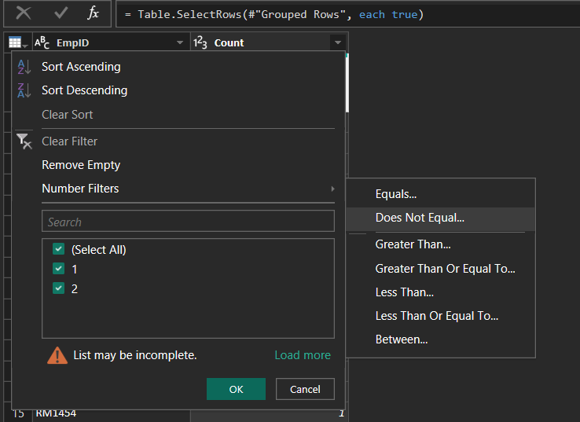

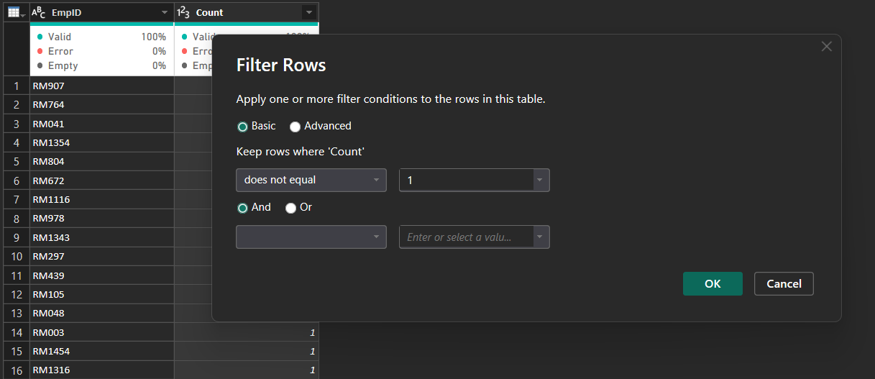
We have duplicate values
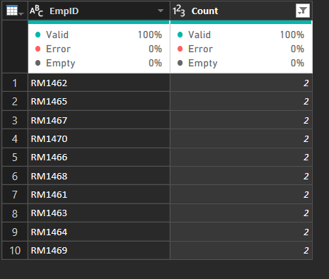
Spelling In-consistence
In Business Travel we have Travel_Rarely and TravelRarely which will confuse the user for the report so,we replace the text value “Travel_Rarely” as TravelRarely
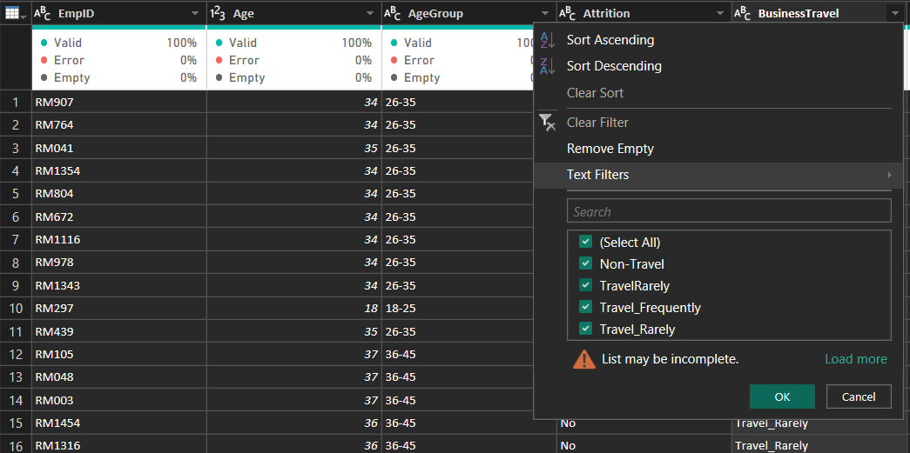
Select a cell(Travel_Rarely) in business Travel column and right click then we get replace value enter TravelRarely
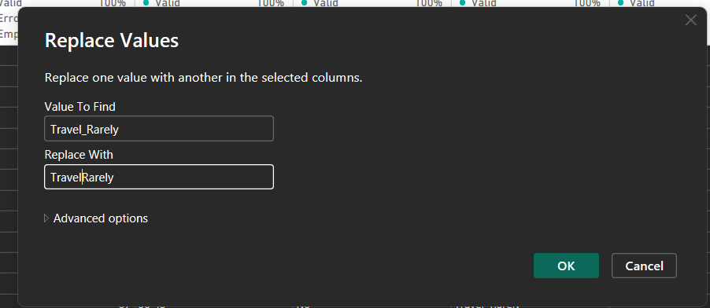
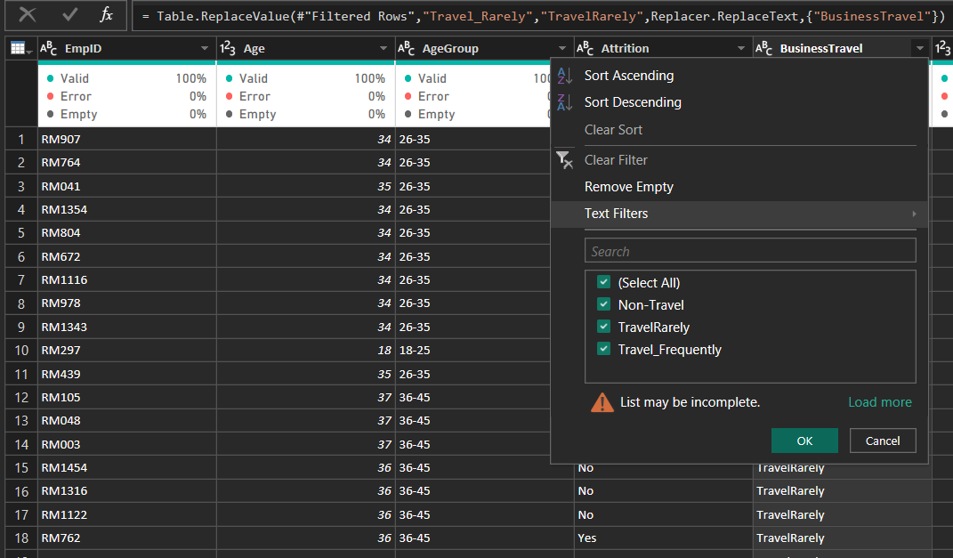
Sometimes,Power BI recognises the column datatype incorrect for example column is identified as Text we need to change it
Go to transform tab and click Detect data type, power BI will automatically detect the datatype
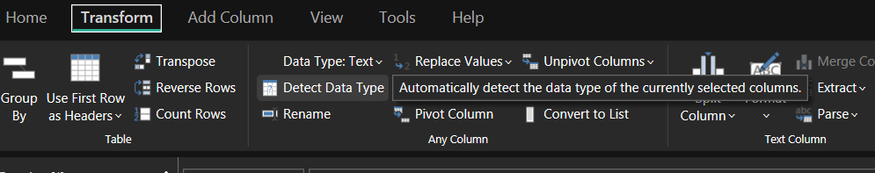
Adding a column for Attrition count
